Consider the following pendulum. Let’s call it a “rebound pendulum”, where a rod has a round mass attached to its end, which is designed to collide with a surface and rebound upon impact. Of interest in this device is the interaction and exchange of energy. Anyone who has ever dribbled a basketball knows they need to apply a sufficient impelling force downward to keep the ball bouncing back up to sufficient height. As the collision between the ball and the ground occurs, there is an exchange of energy. Energy is lost in the form of friction, heat, and sound which prevents the ball from rebounding unmotivated (unforced) to its initial height. Even different materials affect the interaction and exchange of this energy.
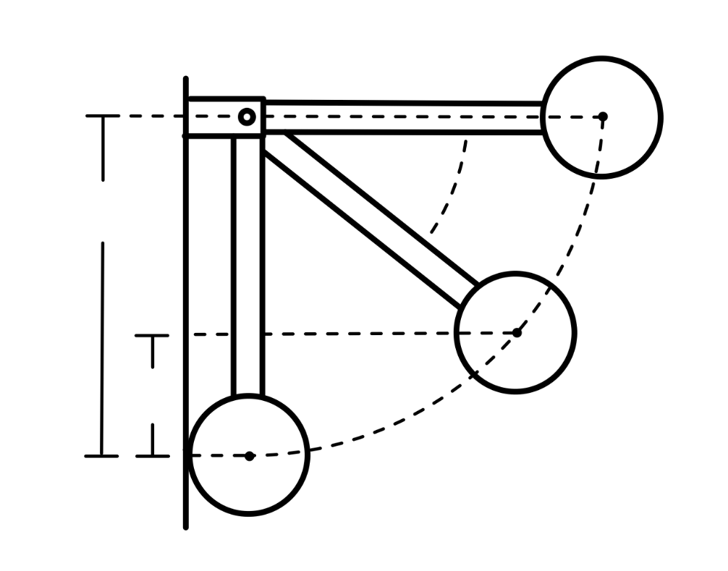
In this rebound pendulum, the pendulum collides with a surface and exchanges energy. If it were possible for all energy to be conserved during the exchange, the pendulum would return to its initial release height (or angle). On the contrary, if it were possible for all energy to be absorbed, the pendulum would impact the material and have no rebound whatsoever (also not realistic).
It then is reasonable to associate the efficiency of the energy exchange with the proportion of release height (or angle) to rebound height (or angle). Though in what way?
Measuring the release and rebound angles would be reasonable next steps. However, what would one then do with such data? What physics backs this relationship, if any?

$$Type equation here.$$
Given that this is a collision problem, and that it would likely be difficult to directly measure the loss of energy, it would be more reasonable to measure the velocity of the pendulum before and after impact. Obtaining a measurement of velocity provides information of the kinetic energy of the system before and after impact and adds alternative perspective to the prior and final potential energies of the system having measured height/angle. Knowing both forms of energy before and after the impact provides two perspectives on the efficiency of the collision.
With measurable data for potential and kinetic energy of the system, this begs the question: What is the underlying physics? How do these parameters (height/angle/velocity) relate to efficiency? Before getting into physics and mathematics, consider how theory and experiment are going to interact.
The (alternative) hypothesis is that height/angle are somehow direct indicators of efficiency.
How does one prosecute this claim?
Measuring the height/angle is trivial, measuring the energy (efficiency) is not.
One is then compelled to measure the energy and compare it to the trivial.
And not merely compare them but compare their ratios.
Along with direct measurement and data analysis (which alone may show a direct relationship), it is important to also consider the underlying physics. And that is the dynamics of the system, which requires some mathematics and some assumptions. To achieve a simplified dynamic analysis of the system, a few assumptions are made.
Assumptions:
- Pendulum is released from an angle of $0°$.
- Pendulum collides perfectly perpendicular to surface.
- The collision surface is stationary.
- The pendulum’s moment of inertia remains constant throughout collision.
- Energy is conserved prior to and following the collision
- Energy is lost during the collision
First, the conversation of energy relations before and after the collision, phase 1 and 2 respectively,
$KE_{1i}+PE_{1i}=KE_{1f}+PE_{1f}$ & $KE_{2i}+PE_{2i}=KE_{2f}+PE_{2f}$
Simplifying, given the pendulum starts from rest and loses all potential energy in phase 1, while starting with a rebound kinetic energy all being converted to potential energy by the end of phase 2.
$PE_{1i}=KE_{1f}$ & $KE_{2i}=PE_{2f}$
Since the pendulum is purely rotating and not translating, kinetic energy only exists in its rotational form. Potential energy purely depends on height.
$mgh_{1i}=\frac{1}{2}Iω_{1f}^{2}$ & $\frac{1}{2}Iω_{2i}^{2}=mgh_{2f}$
Note that, assuming the mass and moment of inertia of the pendulum remain constant, the angular velocities are directly proportional to the heights. By solving both relationships for the moment of inertia, $I$,
$I=\frac{2mgh_{1i}}{ω_{1f}^{2}}$ & $I=\frac{2mgh_{2f}}{ω_{2i}^{2}}$
The ratio now becomes clear.
$$\frac{2mgh_{1i}}{ω_{1f}^{2}}=\frac{2mgh_{2f}}{ω_{2i}^{2}}$$
$$\frac{h_{1i}}{ω_{1f}^{2}}=\frac{h_{2f}}{ω_{2i}^{2}}$$
$$\frac{h_{2f}}{h_{1i}}=\frac{ω_{2i}^{2}}{ω_{1f}^{2}}$$
This proportional essentially says that the ratio of output potential energy to input potential energy is equal to the ratio of output kinetic energy to input kinetic energy. Beautiful!
This relation further compels the motivation to measure not just height/angle but also velocity!
Measuring angular velocity is possible. Relating the angular speed to linear speed is simple, and in fact is identical given the radius of curvature remains constant (the pendulum’s center of gravity arc from the rotation axis).
$$\frac{h_{2f}}{h_{1i}}=\frac{ω_{2i}^{2}}{ω_{1f}^{2}}=\frac{v_{2i}^{2}/r}{v_{1f}^{2}/r}=\frac{v_{2i}^{2}}{v_{1f}^{2}}$$
$$\frac{h_{2f}}{h_{1i}}=\frac{v_{2i}^{2}}{v_{1f}^{2}}$$
One could stop here and proceed to measure the release/rebound heights and velocities, and compare the proportions as prescribed previously.
However, the connection can be taken further. The ratio of heights can be related to the rebound angle and the ratio of velocities can be related to a coefficient often used in dynamical analysis of collisions called the coefficient of restitution.
The coefficient of restitution for a two-particle collision is defined as:
$$e=\frac{v_{B2}-v_{A2}}{v_{A1}-v_{B1}}$$
Where $v_{A}$ is the velocity of one particle, and $v_{B}$ is the velocity of the other particle (1 – before, 2 – after). Since the collision material (B) is assumed to be stationary, its velocity is zero before and after the collision. Before the collision, the pendulum (A) is moving left (negative). After the collision, the pendulum is moving right (positive). Then,
$$e=\frac{0-v_{2i}}{-v_{1f}-0}=\frac{v_{2i}}{v_{1f}}$$
Which says that the coefficient of restitution for this system is the ratio of the rebound velocity to the inbound velocity. This is another beautiful ratio, which relates directly to the inbound/rebound heights as seen earlier. Now,
$$\frac{h_{2f}}{h_{1i}}=\frac{v_{2i}^{2}}{v_{1f}^{2}}=e^{2}$$
This also says that the coefficient of restitution is a measure of energy efficiency (ratio of energies).
But how do the heights relate to the angles? If a relationship between angles can be made, then there are three ways of measuring this coefficient of restitution, which has something to do with energy efficiency (it may already be clear that the coefficient of restitution IS efficiency, though this will become clearer soon).
Using a bit of geometry based on the arc traced out by the radius of the pendulum’s center of gravity. Note that this radius is also the height of the pendulum above the zero-potential datum. The rebound height can be used to create a triangle with a hypotenuse equal to the radius of the pendulum, while the vertical leg of the triangle is the rebound height subtracted from the inbound height.
By property of cosine, the rebound angle can be related to these heights as,
$$cosθ_{f}=\frac{h_{1i}-h_{2f}}{h_{1i}}$$
$$cosθ_{f}=1-\frac{h_{2f}}{h_{1i}}$$
Notice that the ratio of heights can be related to the coefficient of restitution,
$$cosθ_{f}=1-e^{2}$$
Before solving this for the coefficient and obtaining another way of measuring this value, consider the two hypothetical scenarios described earlier. If all energy is conserved, the rebound angle would be the same as the inbound angle. If this were to occur,
$$cos90°=0=1-e^{2}$$
Which requires $e^{2}=1$, and $e=1$. On the contrary, if all energy was absorbed, the rebound angle would be $0°$, so,
$$cos0°=1=1-e^{2}$$
Which requires $e^{2}=0$, and $e=0$.
As seen earlier, the restitution coefficient squared is equal to ratios of energy, so it seems reasonable to conclude that this is the efficiency of the collision.
After solving for the coefficient of restitution in terms of the rebound angle, the following relationships can be made to relate efficiency to the coefficient of restitution, rebound angle, inbound and rebound heights and velocities.
$$ε=e^{2}=1-cosθ_{f}=\frac{h_{2f}}{h_{1i}}=\frac{v_{2i}^{2}}{v_{1f}^{2}}$$
With these relationships, measurements of the rebound angle, rebound height, and inbound/rebound velocities are motivated (assuming the inbound angle and height).
These measurements will allow for a look into the relationship between energy efficiency and the coefficient of restitution.
Given that it is possible to measure the coefficient of restitution with these three methods, it is also possible to obtain experimental values for the coefficient of restitution so it would be interesting to select materials with known restitution coefficients and “predict” the rebound parameters and compare to theory.
The other interesting thing to investigate regarding this relationship is the lack of dependency on mass or length. Galileo showed that the oscillation frequency (energy) depends does not depend on mass though it does depend on length.
Here, not even length is a factor. So, the null hypothesis here would be that length is a factor, while the alternative hypothesis is that length is not a factor. This ought to be investigated!
- Showed relationship between efficiency, restitution coefficient, rebound angle, inbound/outbound heights and velocities.
- Need to measure angle, height, velocity to corroborate efficiency and coefficient.
- Need to use known coefficients to predict/measure/compare rebound angles.
- Need to vary length to test effect.

